**网络技术实践**

**实验报告**

**学号：1120141831**

**姓名：朴泉宇**

**班级：07111403**

**北京理工大学**

**计算机学院**

**2017年11月**

**第二部分**

**网络配置(工程)**

**小组成员:宋傲、刘洪毅、林理露、朴泉宇、谷飒、许晟华、颜航**

**Lab Exercise 4 Inter-VLAN Routing on Routers**

Directory

**Objectives** 1

**Requirements** 1

**Routing** 2

**Dynamic Routing** 2

**Static Routing** 2

**Default Route** 2

**Routing Table** 3

**RIP** 4

**Step 1: Configure Router-on-a-Stick** 5

**Step 2: Configure Static Route** 10

**Step 3: Configure Default Route** 13

**Step 4: Configure a Basic RIP Network** 16

# **Objectives**

* Consolidate what we have learned about VLAN configuration.
* Understand the basics of inter-VLAN routing and routers.
* Giving you an in-depth view on how VLAN routing of router can be setup to implement inter-VLAN communication.

# **Requirements**

**Wireshark:** This lab uses the Wireshark software tool to capture and examine a packet trace.

**ping:** This lab uses “ping” to send and receive messages. The ping command is used to verify that a device can communicate with another on a network.

**traceroute / tracert:** This lab uses “traceroute” or “tracert” to find the router level path.

**rip:** one of the most commonly used interior gateway protocol (IGP) routing protocols on internal networks.

**S3100:** H3C Layer 2 switch.

**S3610:** H3C Layer 3 switch with built-in routing capabilities.

**MSR2040:** H3C multiple services routers.

**Turn in**

Hand in the exercise report including your answers to the questions, screens you capture and trace file you saved.

## **Routing**

Routing is the process of selecting best paths in a network. Routing is one of the most essential procedures in data communication. It ensures that data travels from one network to another with optimal speed and minimal delay, and that its integrity is maintained in the process.

Routing is a key feature of the [Internet](http://www.webopedia.com/TERM/I/Internet.html) because it enables messages to pass from one computer to another and eventually reach the target machine. Each intermediary computer performs routing by passing along the message to the next computer. Part of this process involves analyzing a ***routing table***to determine the best path.

Routing is said to contain three elements:

* Routing protocols, the things that allow information to be gathered and distributed
* Routing algorithms, to determine paths
* Routing databases to store information that the algorithm has discovered. The routing database sometimes corresponds directly to routing table entries, sometimes not.

Broadly, routing is performed in two different ways: dynamic routing and static routing.

## **Dynamic Routing**

Dynamic routing is a networking technique that provides optimal data routing. Unlike static routing, dynamic routing enables routers to select paths according to real-time logical network layout changes. In dynamic routing, the routing protocol operating on the router is responsible for the creation, maintenance and updating of the dynamic routing table. In static routing, all these jobs are manually done by the system administrator.

Dynamic routing uses multiple algorithms and protocols. The most popular are Routing Information Protocol (RIP) and Open Shortest Path First (OSPF).

## **Static Routing**

Static routing is a type of network routing technique. Static routing is not a routing protocol; instead, it is the manual configuration and selection of a network route, usually managed by the network administrator. Unlike [dynamic routing](http://en.wikipedia.org/wiki/Dynamic_routing), static routes are fixed and do not change if the network is changed or reconfigured.

Static routes are normally implemented in those situations where the choices in route selection are limited, or there is only a single default route available. Also, static routing can be used if you have only few devices for route configuration and there is no need for route change in the future.

Static routing and [dynamic routing](http://en.wikipedia.org/wiki/Dynamic_routing) are not mutually exclusive. Both dynamic routing and static routing are usually used on a router to maximize routing efficiency and to provide backups in the event that dynamic routing information fails to be exchanged.

## **Default Route**

A default route of a computer is the [packet](http://en.wikipedia.org/wiki/Packet_(information_technology)) forwarding rule (route) taking effect when no other route can be determined for a given [Internet Protocol](http://en.wikipedia.org/wiki/Internet_Protocol) (IP) destination address. All packets for destinations not established in the [routing table](http://en.wikipedia.org/wiki/Routing_table) are sent via the default route.

The default route in IPv4 is designated as the zero-address [0.0.0.0](http://en.wikipedia.org/wiki/0.0.0.0)/0 in [CIDR notation](http://en.wikipedia.org/wiki/CIDR_notation).

## **Routing Table**

Each host with a router in the network uses the routing table information to determine the next host to route a [packet](http://searchnetworking.techtarget.com/definition/packet) to for a specified destination.

A routing table, or routing information base (RIB), is a [data table](http://en.wikipedia.org/wiki/Data_table) stored in a [router](http://en.wikipedia.org/wiki/Router_(computing)) or a networked [computer](http://en.wikipedia.org/wiki/Computer) that lists the routes to particular network destinations, and in some cases, [metrics](http://en.wikipedia.org/wiki/Metrics_(networking)) (distances) associated with those routes. The routing table contains information about the [topology](http://en.wikipedia.org/wiki/Network_topology) of the network immediately around it. The construction of routing tables is the primary goal of [routing protocols](http://en.wikipedia.org/wiki/Routing_protocol).[Static routes](http://en.wikipedia.org/wiki/Static_route) are entries made in a routing table by non-automatic means and which are fixed rather than being the result of some network topology "discovery" procedure.

Each entry in the routing table defines a route. The routing table will contain at least one entry: **the default route**. This route typically forwards the datagram to the default gateway for the local subnet. There are two other types of routes:

* Network routes
* Host routes

Network routes are entries that contain information on how to reach a specific network ID (a network or subnet) within the internetwork. A host route provides information to reach a particular node or host on a particular network or subnet.

A typical IP routing table entry contains the following information:

1. Network ID or host route internetwork address.
2. Subnet mask (net mask), used to determine the network ID from the IP address.
3. Forwarding address or gateway. (This may be the address of the network interface that is attached to the network, if the address is on a network/subnet to which the router is directly attached.)
4. Port number (or other logical identifier) of the network interface used to forward packets to the network ID.
5. The metric, which is a number that indicates the preference level or priority of a particular route (with the lowest metric usually indicating the most preferred route). The metric indicates the cost of using a particular route; usually it is expressed as the number of hops (the number of routers that must be crossed) to reach a particular destination.

In addition to the default route, the routing table may contain routes to the loopback network address (127.0.0.0), the local network, the local IP address of the host, and multicast and broadcast addresses. Table 3-1 is an example of what the table above could look like on an average compute.

|  |  |  |  |  |
| --- | --- | --- | --- | --- |
| Table 4-1 Routing table | | | | |
| **Network Destination** | **Netmask** | **Gateway** | **Interface** | **Metric** |
| 0.0.0.0 | 0.0.0.0 | 192.168.0.1 | 92.168.0.100 | 10 |
| 127.0.0.0 | 255.0.0.0 | 127.0.0.1 | 127.0.0.1 | 1 |
| 192.168.0.0 | 255.255.255.0 | 192.168.0.100 | 192.168.0.100 | 10 |
| 192.168.0.100 | 255.255.255.255 | 127.0.0.1 | 127.0.0.1 | 10 |
| 192.168.0.1 | 255.255.255.255 | 192.168.0.100 | 192.168.0.100 | 10 |

## **RIP**

Routing Information Protocol (RIP) is a standards-based, distance-vector, interior gateway protocol (IGP) used by routers to exchange routing information. RIP uses hop count to determine the best path between two locations. Hop count is the number of routers the packet must go through till it reaches the destination network. The maximum allowable number of hops a packet can traverse in an IP network implementing RIP is 15 hops, meaning that 16 is deemed unreachable. RIP works well in small networks, but it's inefficient on large networks with slow WAN links or on networks with a large number of routers installed.

In a RIP network, each router broadcasts its entire RIP table to its neighboring routers every 30 seconds. When a router receives a neighbor's RIP table, it uses the information provided to update its own routing table and then sends the updated table to its neighbors.

Typically, RIP uses [UDP](https://wiki.wireshark.org/UDP) as its transport protocol. The well-known UDP port for RIP traffic is 520.

# **Step 1: Configure Router-on-a-Stick**

**Virtual Interface**

The router or layer 3 device interface port connected to the switch must be configured with logical interfaces called virtual interface or sub-interface - one for each VLAN, this is achieved by setting the interface to trunk with encapsulation.

A single Router can utilize an 802.1q trunk link to place a sub-interface in each VLAN using a single physical link and technically have interfaces in all VLAN’s.

**VLAN Termination**

VLAN termination assigns a VLAN-tagged packet received to the corresponding interface according to its VLAN tags, and then the interface removes its VLAN tags, and forwards it through Layer 3 or processes it in another way. Whether the packet is tagged before being sent out depends on the configuration of the outgoing interface. Before sending a packet, the port adds a VLAN tag to the packet according to the VLAN termination configuration on the port.

**VLAN Termination Types**

VLAN termination includes the following types:

* Dot1q termination—Terminates packets which carry one or more layers of VLAN tags and whose outermost VLAN tags match the configured values. Packets sent out of a Dot1q termination interface are single-tagged.
* QinQ termination—Terminates packets which carry two or more layers of VLAN tags and whose outermost two layers of tags match the configured values. Packets sent out of a QinQ termination interface are double-tagged.

The MSR series routers support only Dot1q termination.**Device used**

Two H3C S3100 switches, one S3610 switch and one MSR2040 router.

**Network Topology**

This network topology is extended to the network topology of Lab exercise 3. A MSR2040 router is added and connected to Layer-3 switch. Based on the configurations of Lab exercise 3, it would be easy for you to finish this configuration.



Figure 4-1 Network Topology of Step 1

**Settings for Network Topology**

|  |  |  |
| --- | --- | --- |
| Table 4-2 Settings for Network Topology in Step 1 | | |
| **Property** | **Settings** |  |
| VLAN ID | VLAN 10, VLAN 20 |  |
| Subnet VLAN 10 | Subnet: 192.168.10.0/24  Default Gateway: **192.168.10.2/24** | Host address:  192.168.10.11 - 192.168.10.254 |
| Subnet VLAN 20 | Subnet: 192.168.20.0/24  Default Gateway: **192.168.20.2/24** | Host address:  192.168.20.11 - 192.168.20.254 |
| L3SA-VLAN Interface to VLAN 10 | IP address: 192.168.10.1/24 |  |
| L3SA-VLAN Interface to VLAN 20 | IP address: 192.168.20.1/24 |  |
| RA-E0/1.10 : sub-interface to VLAN 10 | IP address: **192.168.10.2/24** |  |
| RA-E0/1.20 : sub-interface to VLAN 10 | IP address: **192.168.20.2/24** |  |

**Tasks**

Allow hosts in different VLANs communicate with each other by configuring Router-on-a-Stick (also named **one-armed-router**) Inter-VLAN routing on router MSR2040.

**Configuration procedure**

1. Keep or restore all the configurations you have done in Lab Exercise 3. If you have not yet completed the configuration required in Lab Exercise 3, finish it first and make sure the configurations are correct.
2. Connect the router to the L3SA (S3610) switch as showed in Figure 4-1. The port Ethernet 1/0/21 of L3SA (S3610) is used as trunk port.
3. Configure L3SA (S3610)

**# Enter system view to enable configuration.**

<L3SA> system-view

**# Configure port Ethernet 1/0/2 as a trunk port permitting the frames of all VLANs to pass through with VLAN tags.**

[L3SA] interface e1/0/21

[L3SA -Ethernet1/0/21] port link-type trunk

[L3SA -Ethernet1/0/21] port trunk permit vlan all

[L3SA -Ethernet1/0/21] quit

**# Display interface information**

[L3SA] display interface Ethernet 1/0/21

**# Display VLAN information**

[L3SA] display vlan 10

[L3SA] display vlan 20

1. Configure RA (MSR2040)

**# Enter system view to enable configuration.**

<H3C> system-view

**# Assign a new name RA to the router.**

[H3C] sysname RA

**# Create sub-interface Ethernet 0/1.10 and assign IP addresses to it.**

[RA] interface ethernet 0/1.10

[RA-Ethernet0/1.10] ip address 192.168.10.2 255.255.255.0

**#Configure sub-interface Ethernet 0/1.10 to terminate packets tagged with VLAN 10.**

[RA-Ethernet0/1.10] vlan-type dot1q vid 10

[RA-Ethernet0/1.10] quit

**# Display interface information**

[RA] display interface brief

[RA] display interface Ethernet 0/1 brief

[RA] display interface Ethernet 0/1

[RA] display interface Ethernet 0/1.10 brief

[RA] display interface Ethernet 0/1.10 **# Create sub-interface Ethernet 0/1.20 and assign IP addresses to it.**

[RA] interface ethernet 0/1.20

[RA-Ethernet0/1.20] ip address 192.168.20.2 255.255.255.0

**#Configure sub-interface Ethernet 0/1.20 to terminate packets tagged with VLAN 20.**

[RA-Ethernet0/1.20] vlan-type dot1q vid 20

[RA-Ethernet0/1.20] quit

**# Display interface information**

[RA] display interface brief

[RA] display interface Ethernet 0/1 brief

[RA] display interface Ethernet 0/1

[RA] display interface Ethernet 0/1.20 brief

[RA] display interface Ethernet 0/1.20

**# Display configuration information of the interfaces in the current system.**

[RA] display ip interface brief

[RA] display ip interface brief Ethernet 0/1 [RA] display ip interface Ethernet 0/1 **# Display VLAN information**

[RA] display vlan 10

[RA] display vlan 20

**# Display brief information about active routes in the routing table.**

[RA] display ip routing-table

**# Display detailed information about all routes in the routing table.**

[RA] display ip routing-table verbose

1. Verify the configurations of the router.
   1. Ping the address192.168.10.2 on RA (MSR2040) router terminal.

ping 192.168.10.2 or ping –r 192.168.10.2

* 1. Ping the address192.168.20.2 on RA (MSR2040) router terminal.

ping 192.168.10.2 or ping –r 192.168.10.2

* 1. Ping PCs of VLAN 10 on RA (MSR2040) router terminal.
  2. Ping PCs of VLAN 20 on RA (MSR2040) router terminal.

If all the ping packets are transmitted and are received by the destination address, the interface is up and working. Or check the configurations until they are correct.

1. **Check and Modify the default gateway address of PCs of VLAN 10 and VLAN 20. Assign 192.168.10.2/24 as the default gateway address to PCs of VLAN 10 and 192.168.20.2/24 as the default gateway address to PCs of VLAN 20.**
2. Verify the connectivity. Ping from PC1 or PC2 in VLAN 10 to PC3 and PC4 in VLAN 20 or vice versa.
3. Check the route the packets pass from PC1 to PC2.

In DOS window of PC1, enter command “tracert 192.168.20.x”. Replace “192.168.20.x” with the IP address of PC2.

**Answer the following questions:**

1. Describe how the sub-interfaces and Dot1q termination are used to route packets between VLANs on the router.

流程如下：

发送方 -> 交换机 -> 路由器 -> 交换机 -> 接收方

1. Paste the screen of the IP routing table of the router that you captured.
2. Paste the result window of command “ping -r 192.168.20.2” on the router.

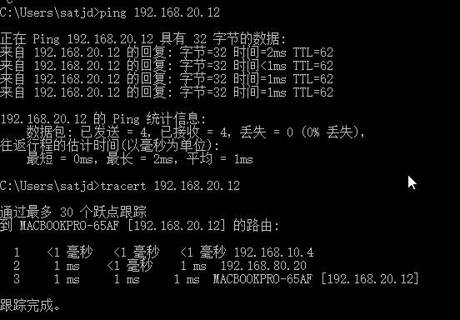

1. Paste the result of command “tracert 192.168.20.x” above.



# **Step 2: Configure Static Route**

**Introduction**

A static route is a special route that is manually configured by the network administrator. If a network’s topology is simple, you only need to configure static routes for the network to work normally. The proper configuration and usage of static routes can improve network performance and ensure bandwidth for important network applications.

The disadvantage of using static routes is that they cannot adapt to network topology changes. If a fault or a topological change occurs in the network, the routes will be unreachable and the network breaks. In this case, the network administrator has to modify the static routes manually.

**Device used**

Two H3C S3100 switches and two MSR2040 routers.

**Network Topology**



Figure 4-2

**Settings for Network Topology**

|  |  |  |
| --- | --- | --- |
| Table 4-3 Settings for Figure 4-2 | | |
| **Property** | **Settings** |  |
| VLAN ID | VLAN 10, VLAN 20 |  |
| Subnet VLAN 10 | Subnet: 192.168.10.0/24  Default Gateway: **192.168.10.4/24** | Host address:  192.168.10.11 - 192.168.10.254 |
| Subnet VLAN 20 | Subnet: 192.168.20.0/24  Default Gateway: **192.168.20.4/24** | Host address:  192.168.20.11 - 192.168.20.254 |
| RA-E0/1 | IP address: **192.168.10.4/24** |  |
| RA-E0/0 | IP address: 192.168.80.10/24 |  |
| RB-E0/1 | IP address: **192.168.20.4/24** |  |
| RB-E0/0 | IP address: 192.168.80.20/24 |  |

**Tasks**

* Connect devices as specified in Figure 4-x.
* Create two VLANs: VLAN 10 and VLAN 20.
* Assign IP addresses to the ports of routers.
* Configure static routes on routers for the communication between any two hosts in different VLANs.
* Verify the connectivity.

**Configuration procedure**

1. Connect devices as specified in the figure.
2. Establish the configuration environments.
3. Create two VLANs (VLAN 10 and VLAN 20) on L2SA and L2SB. You have learned how to do it in previous labs.
4. Check and assign IP addresses to PCs of VLAN 10 and VLAN 20. **Assign 192.168.10.4/24 as the default gateway address to PCs of VLAN 10 and 192.168.20.4/24 as the default gateway address to PCs of VLAN 20.**
5. Configure IP addresses for interfaces on router RA (MSR2040).

**# Enter system view to enable configuration.**

<H3C> system-view

**# Assign a new name RA to the router.**

[H3C] sysname RA

**# Assign IP addresses to port Ethernet 0/1.**

[RA] interface ethernet 0/1

[RA-Ethernet0/1] ip address 192.168.10.4 255.255.255.0

**# Assign IP addresses to port Ethernet 0/0.**

[RA] interface ethernet 0/0

[RA-Ethernet0/0] ip address 192.168.80.10 255.255.255.0

[RA-Ethernet0/0] quit

**# Display brief information about active routes in the routing table of RA.**

[RA] display ip routing-table

**# Display detailed information about all routes in the routing table.**

[RA] display ip routing-table verbose

**Answer the following questions:**

1. Paste the routing table (before configuring a static route) of RA here.

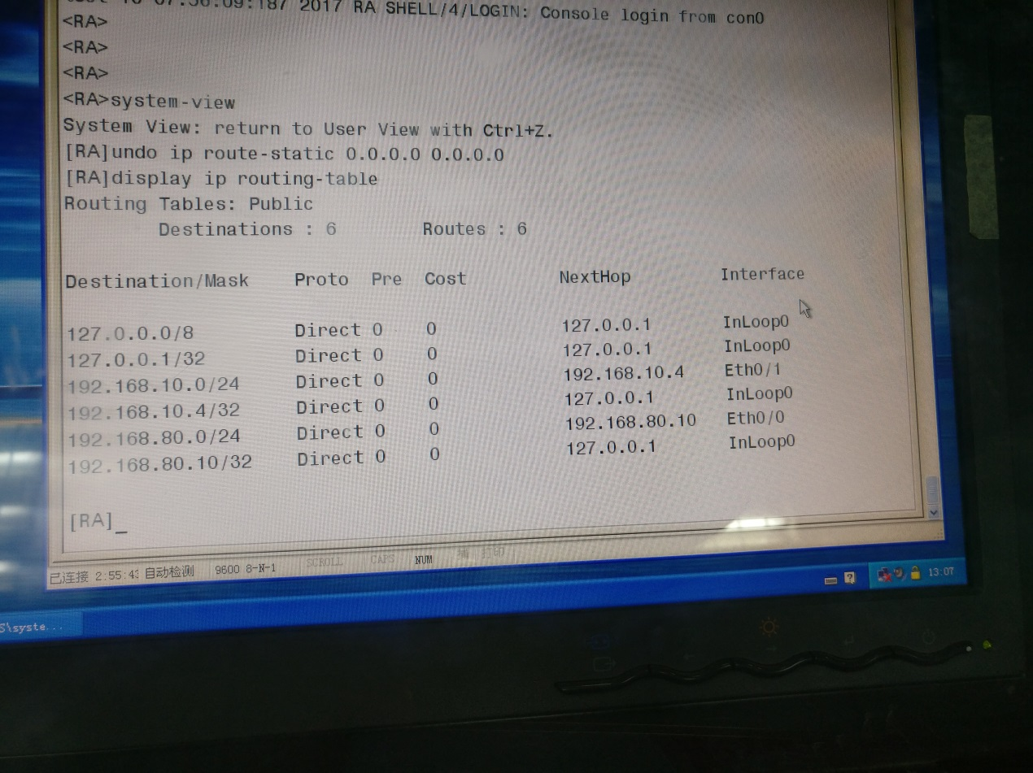

1. Configure IP addresses for interfaces on router RB (MSR2040).

**# Enter system view to enable configuration.**

<H3C> system-view

**# Assign a new name RB to the router.**

[H3C] sysname RB

**# Assign IP addresses to port Ethernet 0/1.**

[RB] interface ethernet 0/1

[RB-Ethernet0/1] ip address 192.168.20.4 255.255.255.0

**# Assign IP addresses to port Ethernet 0/0.**

[RB] interface ethernet 0/0

[RB-Ethernet0/0] ip address 192.168.80.20 255.255.255.0

[RB-Ethernet0/0] quit

**# Display brief information about active routes in the routing table of RA.**

[RB] display ip routing-table

**# Display detailed information about all routes in the routing table.**

[RB] display ip routing-table verbose

**Answer the following questions:**

1. Paste the routing table (before configuring a static route) of RB here.

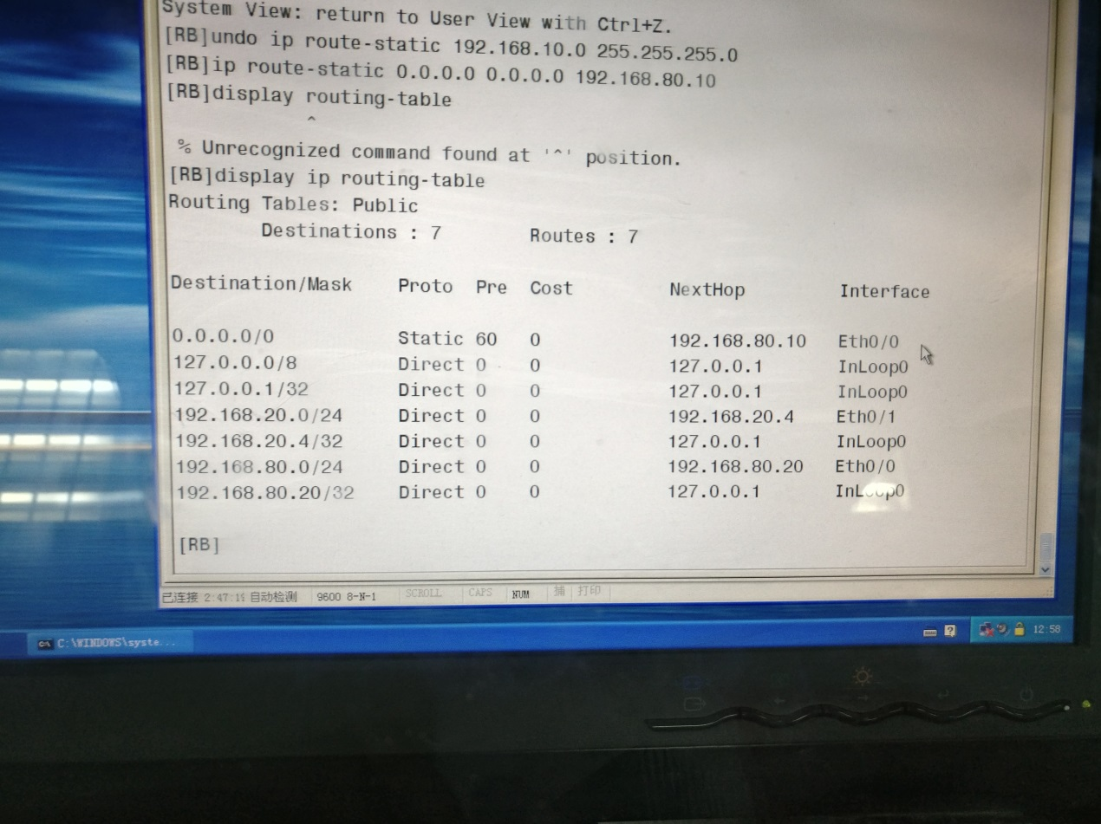

1. Can you ping from RA to PC1 or PC2? Why?

可以。有虚接口，可以通信。

1. Can you ping from RB to PC3 or PC4? Why?

可以。有虚接口，可以通信。

1. Can you ping from RA to RB? Why?

不可以。RA和RB之间没有虚接口。

1. Can you ping from PC1 or PC2 in VLAN 10 to PC3 or PC4 in VLAN 20 or vice versa? Why?

不可以。RA和RB之间没有虚接口，不可以通信。

1. Configure static routes for router RA (MSR2040) and RB (MSR2040).

**# Configure a static route on RA**

<RA> system-view

[RA] ip route-static 192.168.20.0 255.255.255.0 192.168.80.20

**# Configure a static route on RB**

<RB> system-view

[RB] ip route-static 192.168.10.0 255.255.255.0 192.168.80.10

1. Display the configuration result

**# Display the IP routing table of RA.**

[RA] display ip routing-table

**# Display the IP routing table of RB.**

[RB] display ip routing-table

**Answer the following questions:**

1. Paste the routing table (after configuring a static route) of RA here. Highlight the static route you configured.

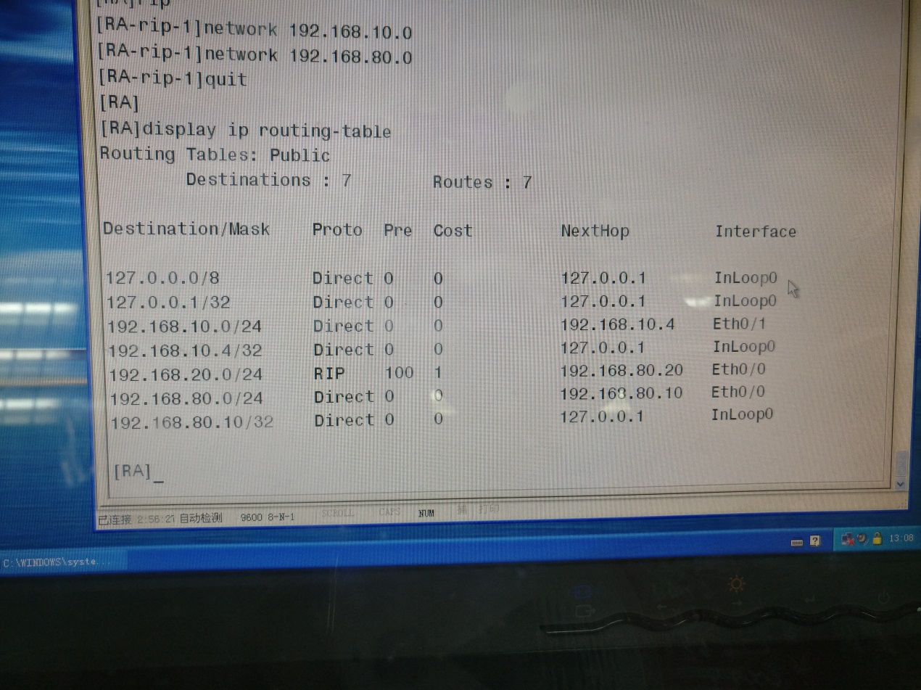

1. Paste the routing table (after configuring a static route) of RB here. Highlight the static route you configured.

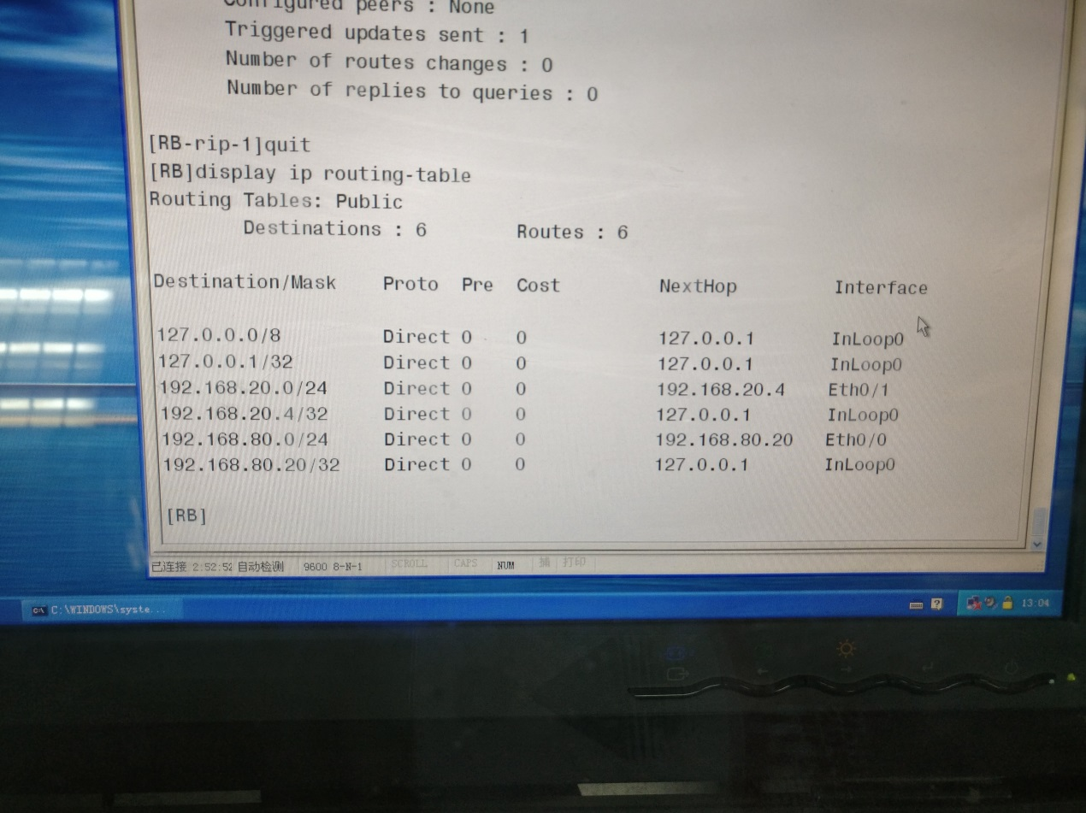

1. Can you ping from PC1 or PC2 in VLAN 10 to PC3 or PC4 in VLAN 20 or vice versa? Why?

可以。路由表里已经存在配置。

1. From PC1, enter the “tracert 192.168.20.x” command. Replace “192.168.20.x” with the IP address of PC3 or PC4. Paste the result of command “tracert 192.168.20.x”.

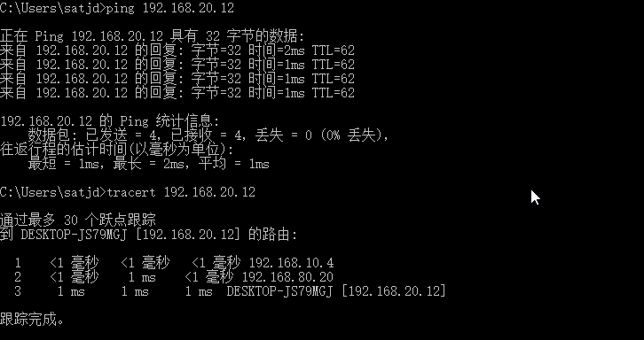

# **Step 3: Configure Default Route**

**Introduction**

A router selects the default route only when it cannot find any matching entry in the routing table.

If the destination address of a packet fails to match any entry in the routing table, the router selects the default route to forward the packet.

If there is no default route and the destination address of the packet fails to match any entry in the routing table, the packet will be discarded and an ICMP packet will be sent to the source to report that the destination or the network is unreachable.

You can create the default route with both destination and mask being 0.0.0.0, and some dynamic routing protocols, such as OSPF, RIP and IS-IS, can also generate the default route.

**Device used**

Two H3C S3100 switches and two MSR2040 routers.

**Network Topology**

The network topology and the settings are same as those in Step 2.

Figure 4-3



**Settings for Network Topology**

|  |  |  |
| --- | --- | --- |
| Table 4-4 Settings for Figure 4-3 | | |
| **Property** | **Settings** |  |
| VLAN ID | VLAN 10, VLAN 20 |  |
| Subnet VLAN 10 | Subnet: 192.168.10.0/24  Default Gateway: **192.168.10.4/24** | Host address:  192.168.10.11 - 192.168.10.254 |
| Subnet VLAN 20 | Subnet: 192.168.20.0/24  Default Gateway: **192.168.20.4/24** | Host address:  192.168.20.11 - 192.168.20.254 |
| RA-E0/1 | IP address: **192.168.10.4/24** |  |
| RA-E0/0 | IP address: 192.168.80.10/24 |  |
| RB-E0/1 | IP address: **192.168.20.4/24** |  |
| RB-E0/0 | IP address: 192.168.80.20/24 |  |

**Tasks**

* Delete static routes you configured in Step 2.
* Configure default routes on routers for the communication between any two hosts in different VLANs.
* Verify the connectivity.

**Configuration procedure**

1. Keep all settings you configured in Step 2.
2. Delete the static routes you configured for router RA and RB in Step 2.

**# delete the static route you configured on RA**

<RA> system-view

[RA] undo ip route-static 192.168.20.0 255.255.255.0

**# delete the static route you configured on RB**

<RB> system-view

[RB] undo ip route-static 192.168.10.0 255.255.255.0

1. Check if the static routes have been deleted from the routing table of RA and RB.

**# Display the IP routing table of RA.**

[RA] display ip routing-table

**# Display the IP routing table of RB.**

[RB] display ip routing-table

1. Configure default routes for router RA (MSR2040) and RB (MSR2040).

**# Configure a static route on RA**

<RA> system-view

[RA] ip route-static 0.0.0.0 0.0.0.0 192.168.80.20

**# Configure a static route on RB**

<RB> system-view

[RB] ip route-static 0.0.0.0 0.0.0.0 192.168.80.10

1. Display the configuration result

**# Display the IP routing table of RA.**

[RA] display ip routing-table

**# Display the IP routing table of RB.**

[RB] display ip routing-table

**Answer the following questions:**

1. Paste the routing table (after configuring a static route) of RA here. Highlight the default route you configured.



1. Paste the routing table (after configuring a static route) of RB here. Highlight the default route you configured.



1. Can you ping from PC1 or PC2 in VLAN 10 to PC3 or PC4 in VLAN 20 or vice versa? Why?’

可以。已经配置了相应接口。

1. From PC1, enter the “tracert 192.168.20.x” command. Replace “192.168.20.x” with the IP address of PC3 or PC4. Paste the result of command “tracert 192.168.20.x”.



# **Step 4: Configure a Basic RIP Network**

**Overview**

RIP is a simple Interior Gateway Protocol (IGP), mainly used in small-sized networks, such as academic networks and simple LANs. RIP is not applicable to complex networks.

RIP is still widely used in practical networking due to easier implementation, configuration and maintenance than OSPF and IS-IS.

RIP v1 is a classful routing protocol but RIP v2 is a classless routing protocol.

**Working Mechanism**

RIP is a distance vector routing protocol, using UDP packets for exchanging information through port 520.

RIP uses a hop count to measure the distance to a destination. The hop count is known as the metric. The hop count from a router to a directly connected network is 0. The hop count from one router to a directly connected router is 1. To limit convergence time, the range of RIP metric value is from 0 to 15. A metric value of 16 (or bigger) is considered infinite, which means the destination network is unreachable. That is why RIP is not suitable for large-scaled networks.

RIP prevents routing loops by implementing the split horizon and poison reverse functions.

**Operation of RIP**

The following procedure describes how RIP works.

1. After RIP is enabled, the router sends Request messages to neighboring routers. Neighboring routers return Response messages including information about their routing tables.
2. After receiving such information, the router updates its local routing table, and sends triggered update messages to its neighbors. All routers on the network do the same to keep the latest routing information.
3. By default, a RIP router sends its routing table to neighbors every 30 seconds.
4. RIP ages out routes by adopting an aging mechanism to keep only valid routes.

**Device used**

Two H3C S3100 switches and two MSR2040 routers.

**Network Topology**

The network topology and the settings are same as those in Step 3.

Figure 4-4



**Settings for Network Topology**

|  |  |  |
| --- | --- | --- |
| Table 4-5 Settings for Figure 4-4 | | |
| **Property** | **Settings** |  |
| VLAN ID | VLAN 10, VLAN 20 |  |
| Subnet VLAN 10 | Subnet: 192.168.10.0/24  Default Gateway: **192.168.10.4/24** | Host address:  192.168.10.11 - 192.168.10.254 |
| Subnet VLAN 20 | Subnet: 192.168.20.0/24  Default Gateway: **192.168.20.4/24** | Host address:  192.168.20.11 - 192.168.20.254 |
| RA-E0/1 | IP address: **192.168.10.4/24** |  |
| RA-E0/0 | IP address: 192.168.80.10/24 |  |
| RB-E0/1 | IP address: **192.168.20.4/24** |  |
| RB-E0/0 | IP address: 192.168.80.20/24 |  |

**Tasks**

* Delete default routes you configured in Step 3.
* Configure a basic RIP network. Enable RIP to allow routers to update their routing tables dynamically and implement the communication between any two hosts in different VLANs.
* Verify the connectivity.

**Configuration procedure**

1. Keep all settings you configured in Step 3.
2. Delete the default routes you configured for router RA and RB in Step 3.

**# delete the default route you configured on RA**

<RA> system-view

[RA] undo ip route-static 0.0.0.0 0.0.0.0

**# delete the static route you configured on RB**

<RB> system-view

[RB] undo ip route-static 0.0.0.0 0.0.0.0

1. Check if the default routes have been deleted from the routing table of RA and RB.

**# Display the IP routing table of RA.**

[RA] display ip routing-table

**# Display the IP routing table of RB.**

[RB] display ip routing-table

1. Configure RIPv1 function on router RA and RB.

**# Start RIP routing process on RA**

<RA> system-view

[RA] rip

**# Enable RIPv1 on all interfaces on RA. This will allow router RA to advertise networks 192.168.10.0 and 192.168.80.0 through RIP.**

[RA-rip-1] network 192.168.10.0

[RA-rip-1] network 192.168.80.0

[RA-rip-1] quit

**# Start RIP routing process on RB**

<RB> system-view

[RB] rip

**# Enable RIPv1 on all interfaces on RA. This will allow router RA to advertise networks 192.168.10.0 and 192.168.80.0 through RIP.**

[RB-rip-1] network 192.168.20.0

[RB-rip-1] network 192.168.80.0

[RB-rip-1] quit

1. Display the configuration result

**# Display the RIP configurations of RA and RB.**

[RA] display rip

[RB] display rip

**# Display the IP routing tables of RA and RB.**

[RA] display ip routing-table

[RB] display ip routing-table

**# Display the RIP routing tables of RA and RB.**

[RA] display rip 1 route

[RA] display rip 1 database

[RB] display rip 1 route

[RB] display rip 1 database

**Answer the following questions:**

1. Paste the RIP configurations of RA here.

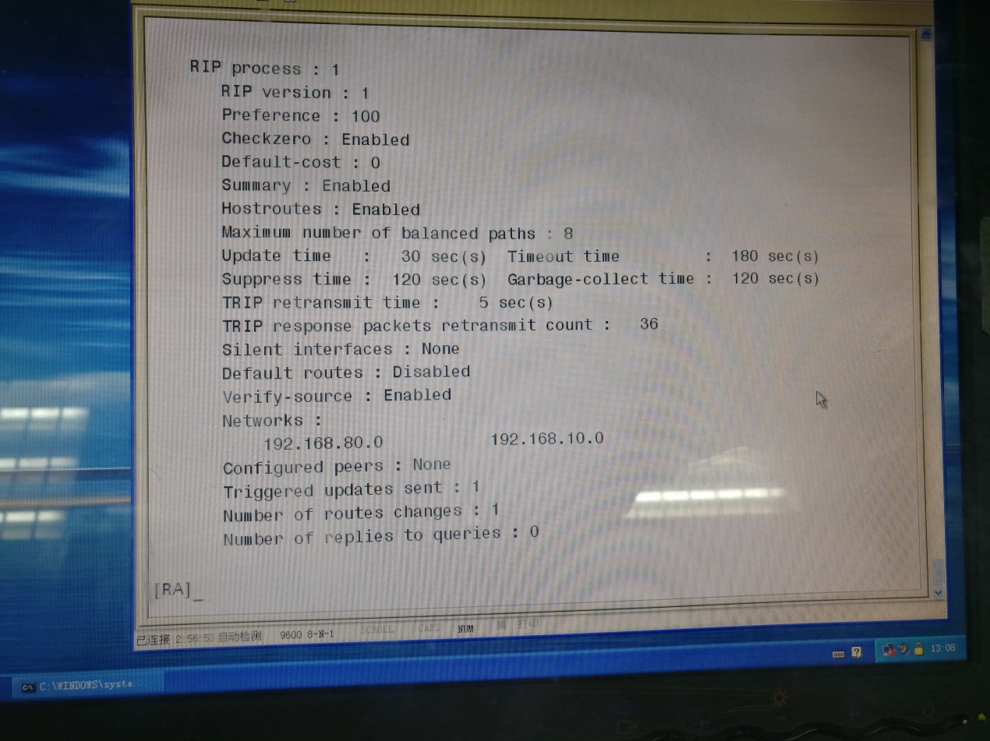

1. Paste the routing table (after configuring RIP) of RA here. Highlight the RIP route.



1. Paste the routing table (after configuring RIP) of RB here. Highlight the RIP route.



1. Paste the RIP routing table of RA here.

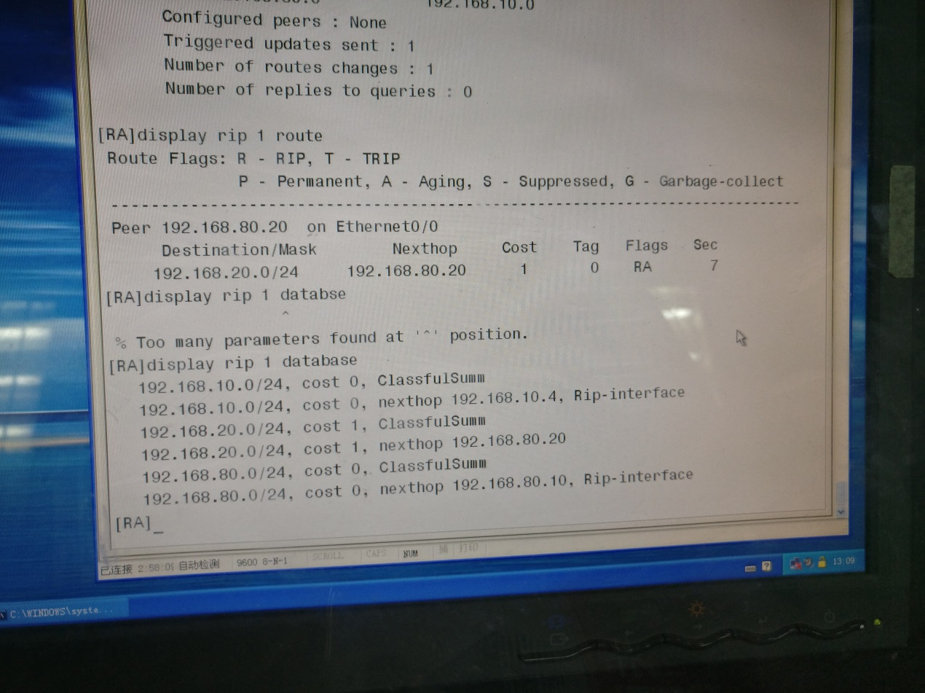

1. Can you ping from PC1 or PC2 in VLAN 10 to PC3 or PC4 in VLAN 20 or vice versa? Why?

不可以。

1. From PC1, enter the “tracert 192.168.20.x” command. Replace “192.168.20.x” with the IP address of PC3 or PC4. Paste the result of command “tracert 192.168.20.x”.

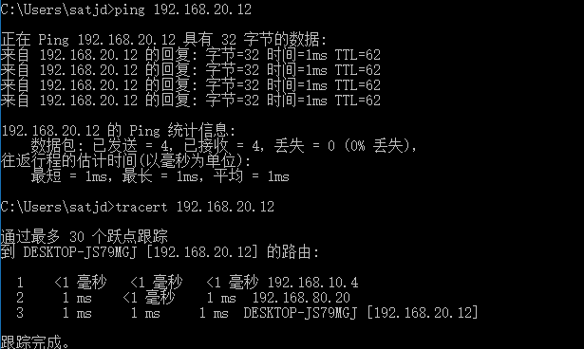

1. Launch **Wireshark** on PC3 and start capturing RIP traffic.

**Answer the following questions:**

1. Paste the detailed information of RIP request and response messages you captured with **Wireshark** here.

